*LAB # 05*

sorting on linear arrays

# *OBJECTIVE:*

*To sort a linear array using Selection Sort, bubble sort and merge sort*

*LAB task*

1. *Write a program for Selection sort that sorts an array containing numbers, prints all*

*the sort values of array each followed by its location.*

**Code:**

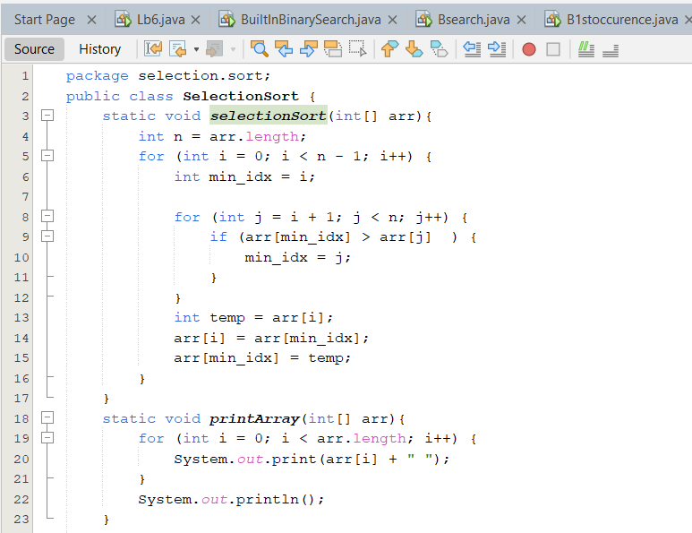

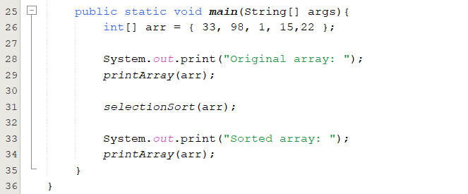

**Output:**

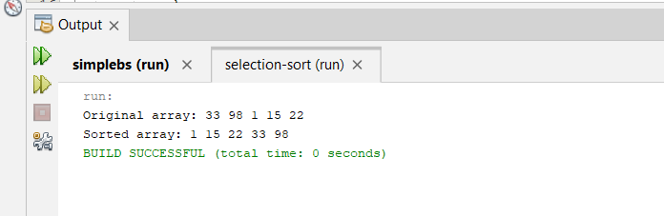

1. *Write a program that takes 10 numbers as input in an array. Sort the elements of array*

*by using Bubble sort. Print each iteration of the sorting process.*

**Code:**

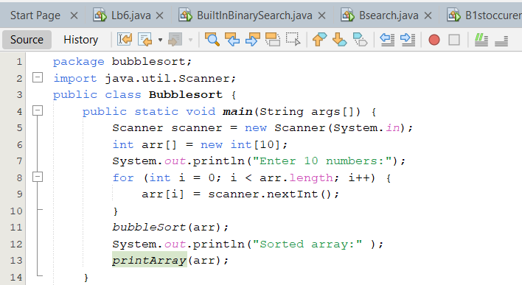

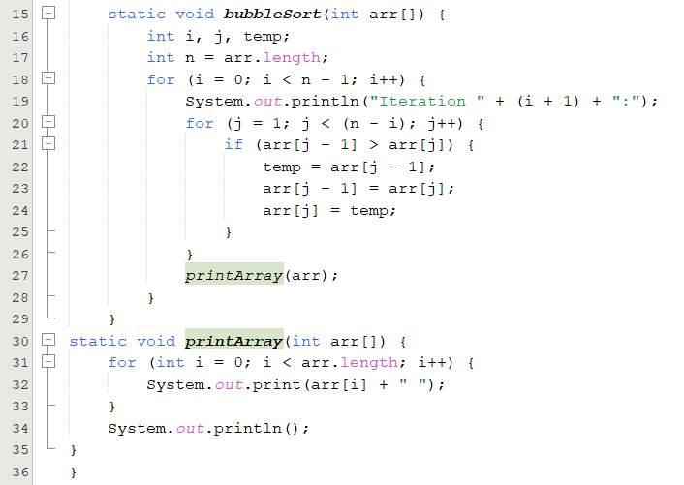

**Output:**

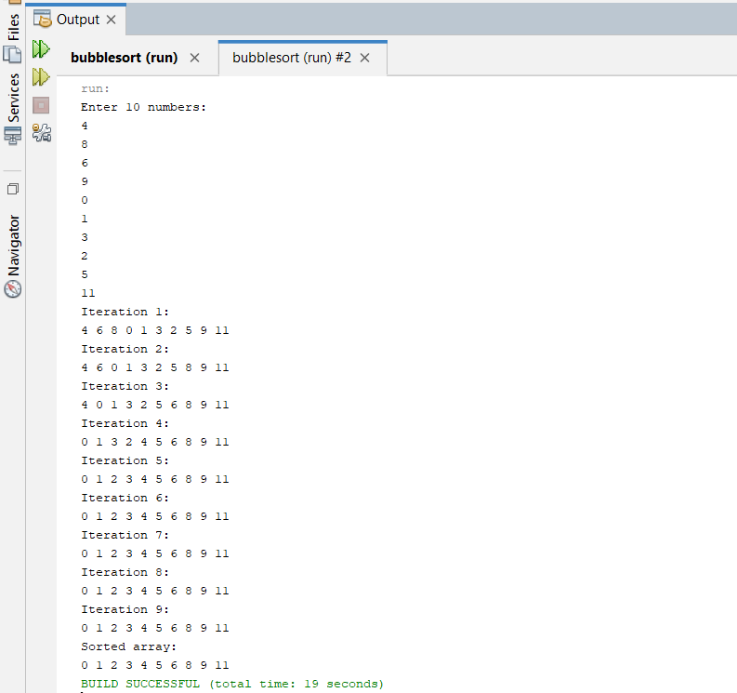

1. *Write a program that takes 10 random numbers in an array. Sort the elements of array*

*by using Merge sort applying recursive technique. Print each iteration of the sorting process*

**Code:**

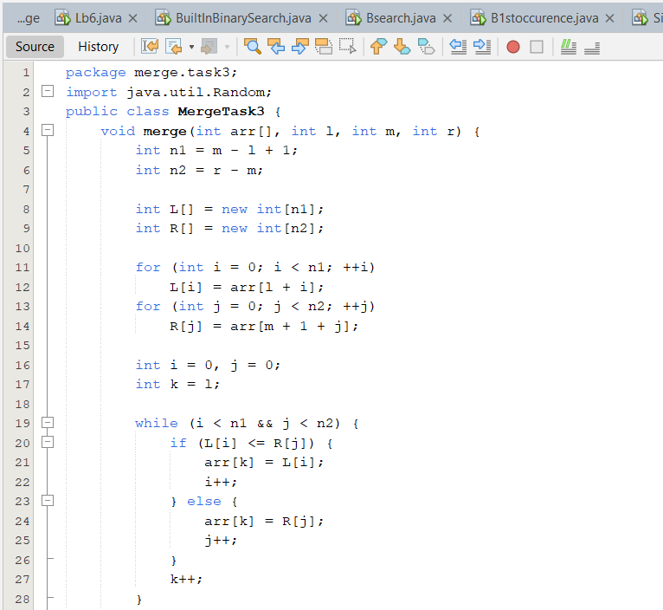

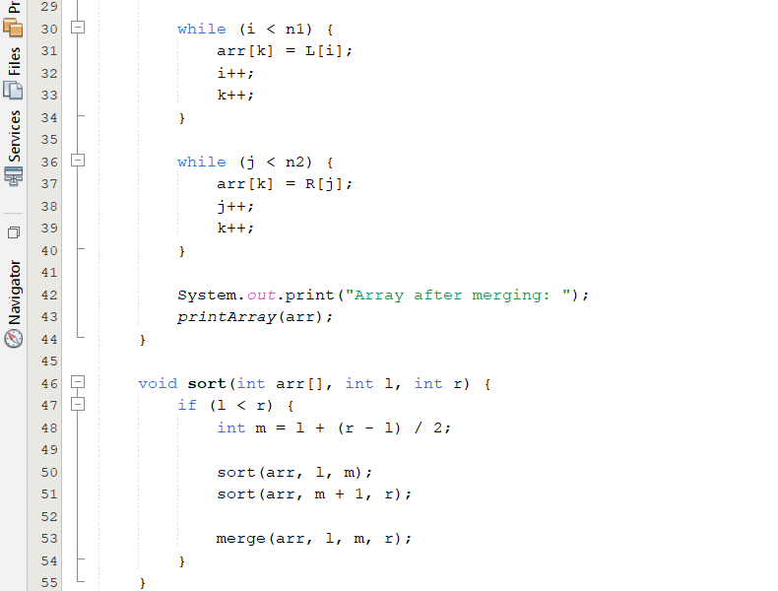

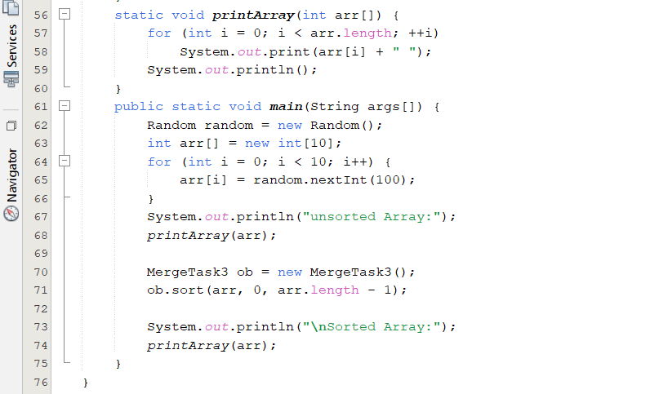

**Output:**

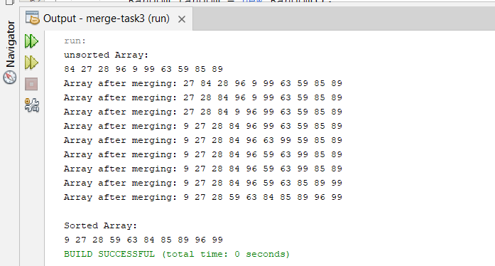

*HOME task*

1. *Write a program which takes an unordered list of integers (or any other objects e.g. String), you have to rearrange the list in their natural order using merge sort.*

**Code:**

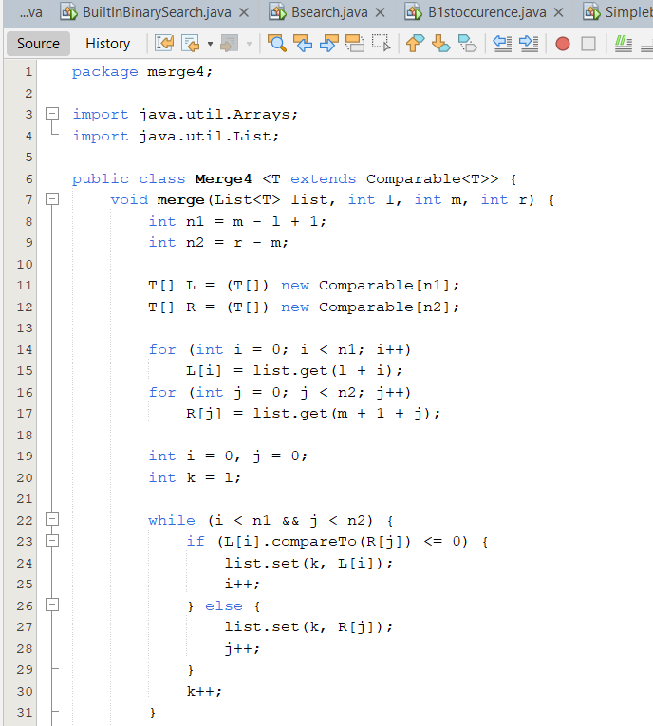

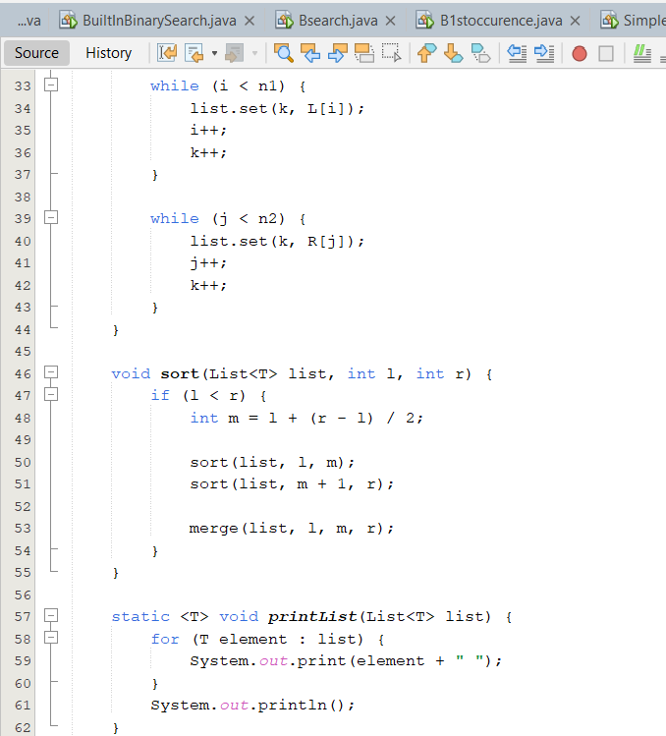

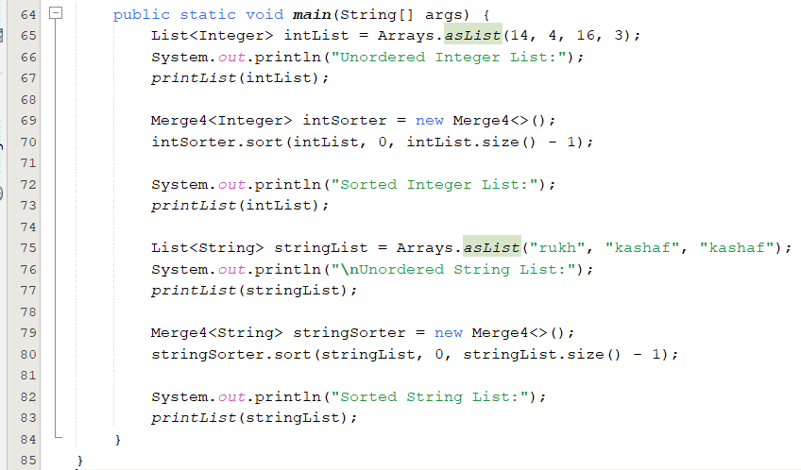

**Output:**

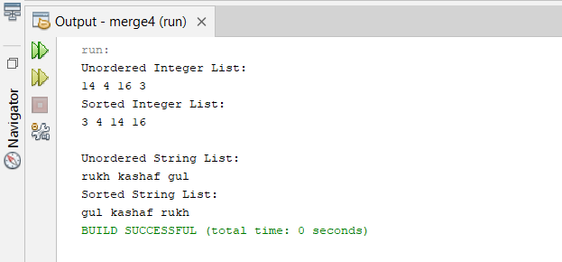

1. *You are given an unordered list of integers or strings. Write a program to Take this list as input. Sort it in* ***natural order*** *using Merge Sort. For integers, this means ascending order. For strings, this means alphabetical order. Print the sorted list.*

**Code:**

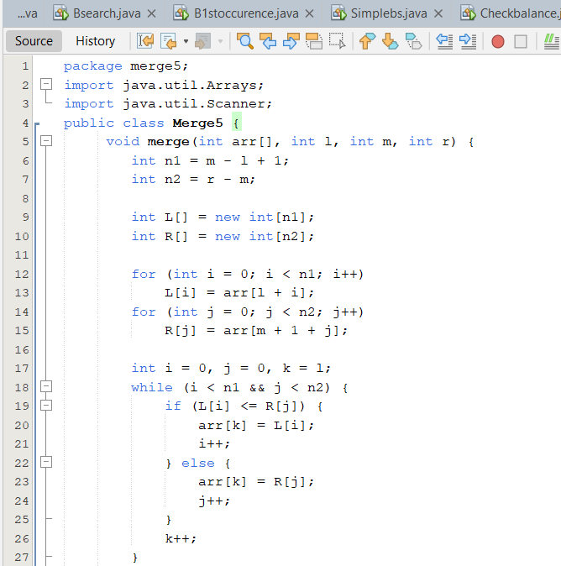

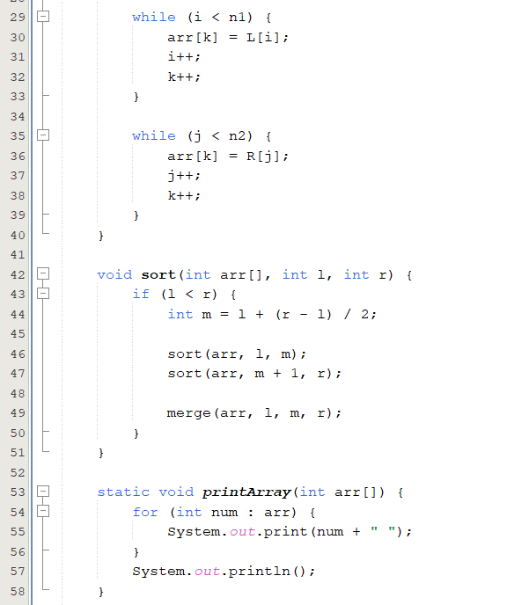

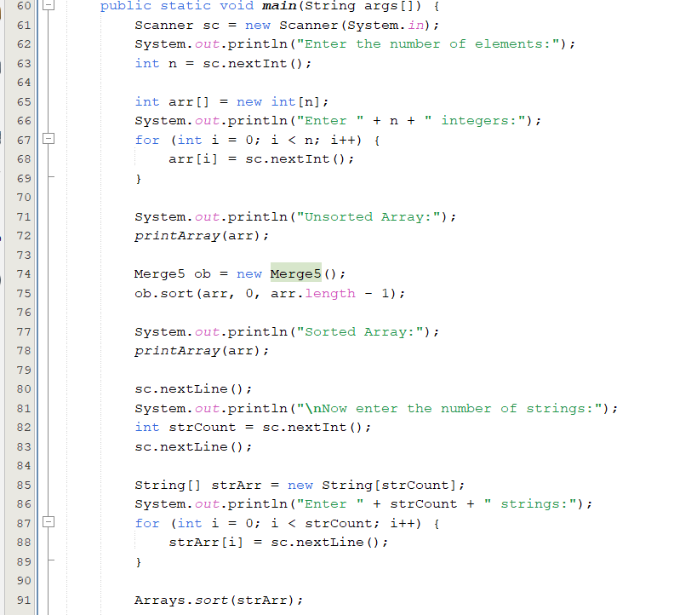

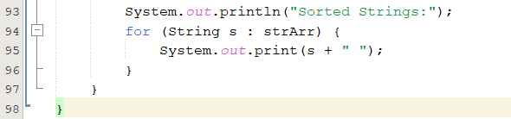

**Output:**

